3’s,4’s and Kid Town Tree Town Newsletter – September/October 2017

Welcome to our first edition of the Tree Town Newsletter! We hope you are getting settled into a routine and enjoying your class. Our newsletter is e-mailed once per month and posted on your class bulletin board. It gives you an idea of what’s going on at school, things to talk about with your child, and future events and dates to plan for.

We are very excited to show off our new playground! The children have been enjoying our new play structure. We also have a “Buddy Bench” donated in memory of our beloved Mrs. Sutherland. The 3’s and 4’s have started a kindness curriculum to tie in with our new bench.

Our 4’s Camper’s enjoying our new bench!

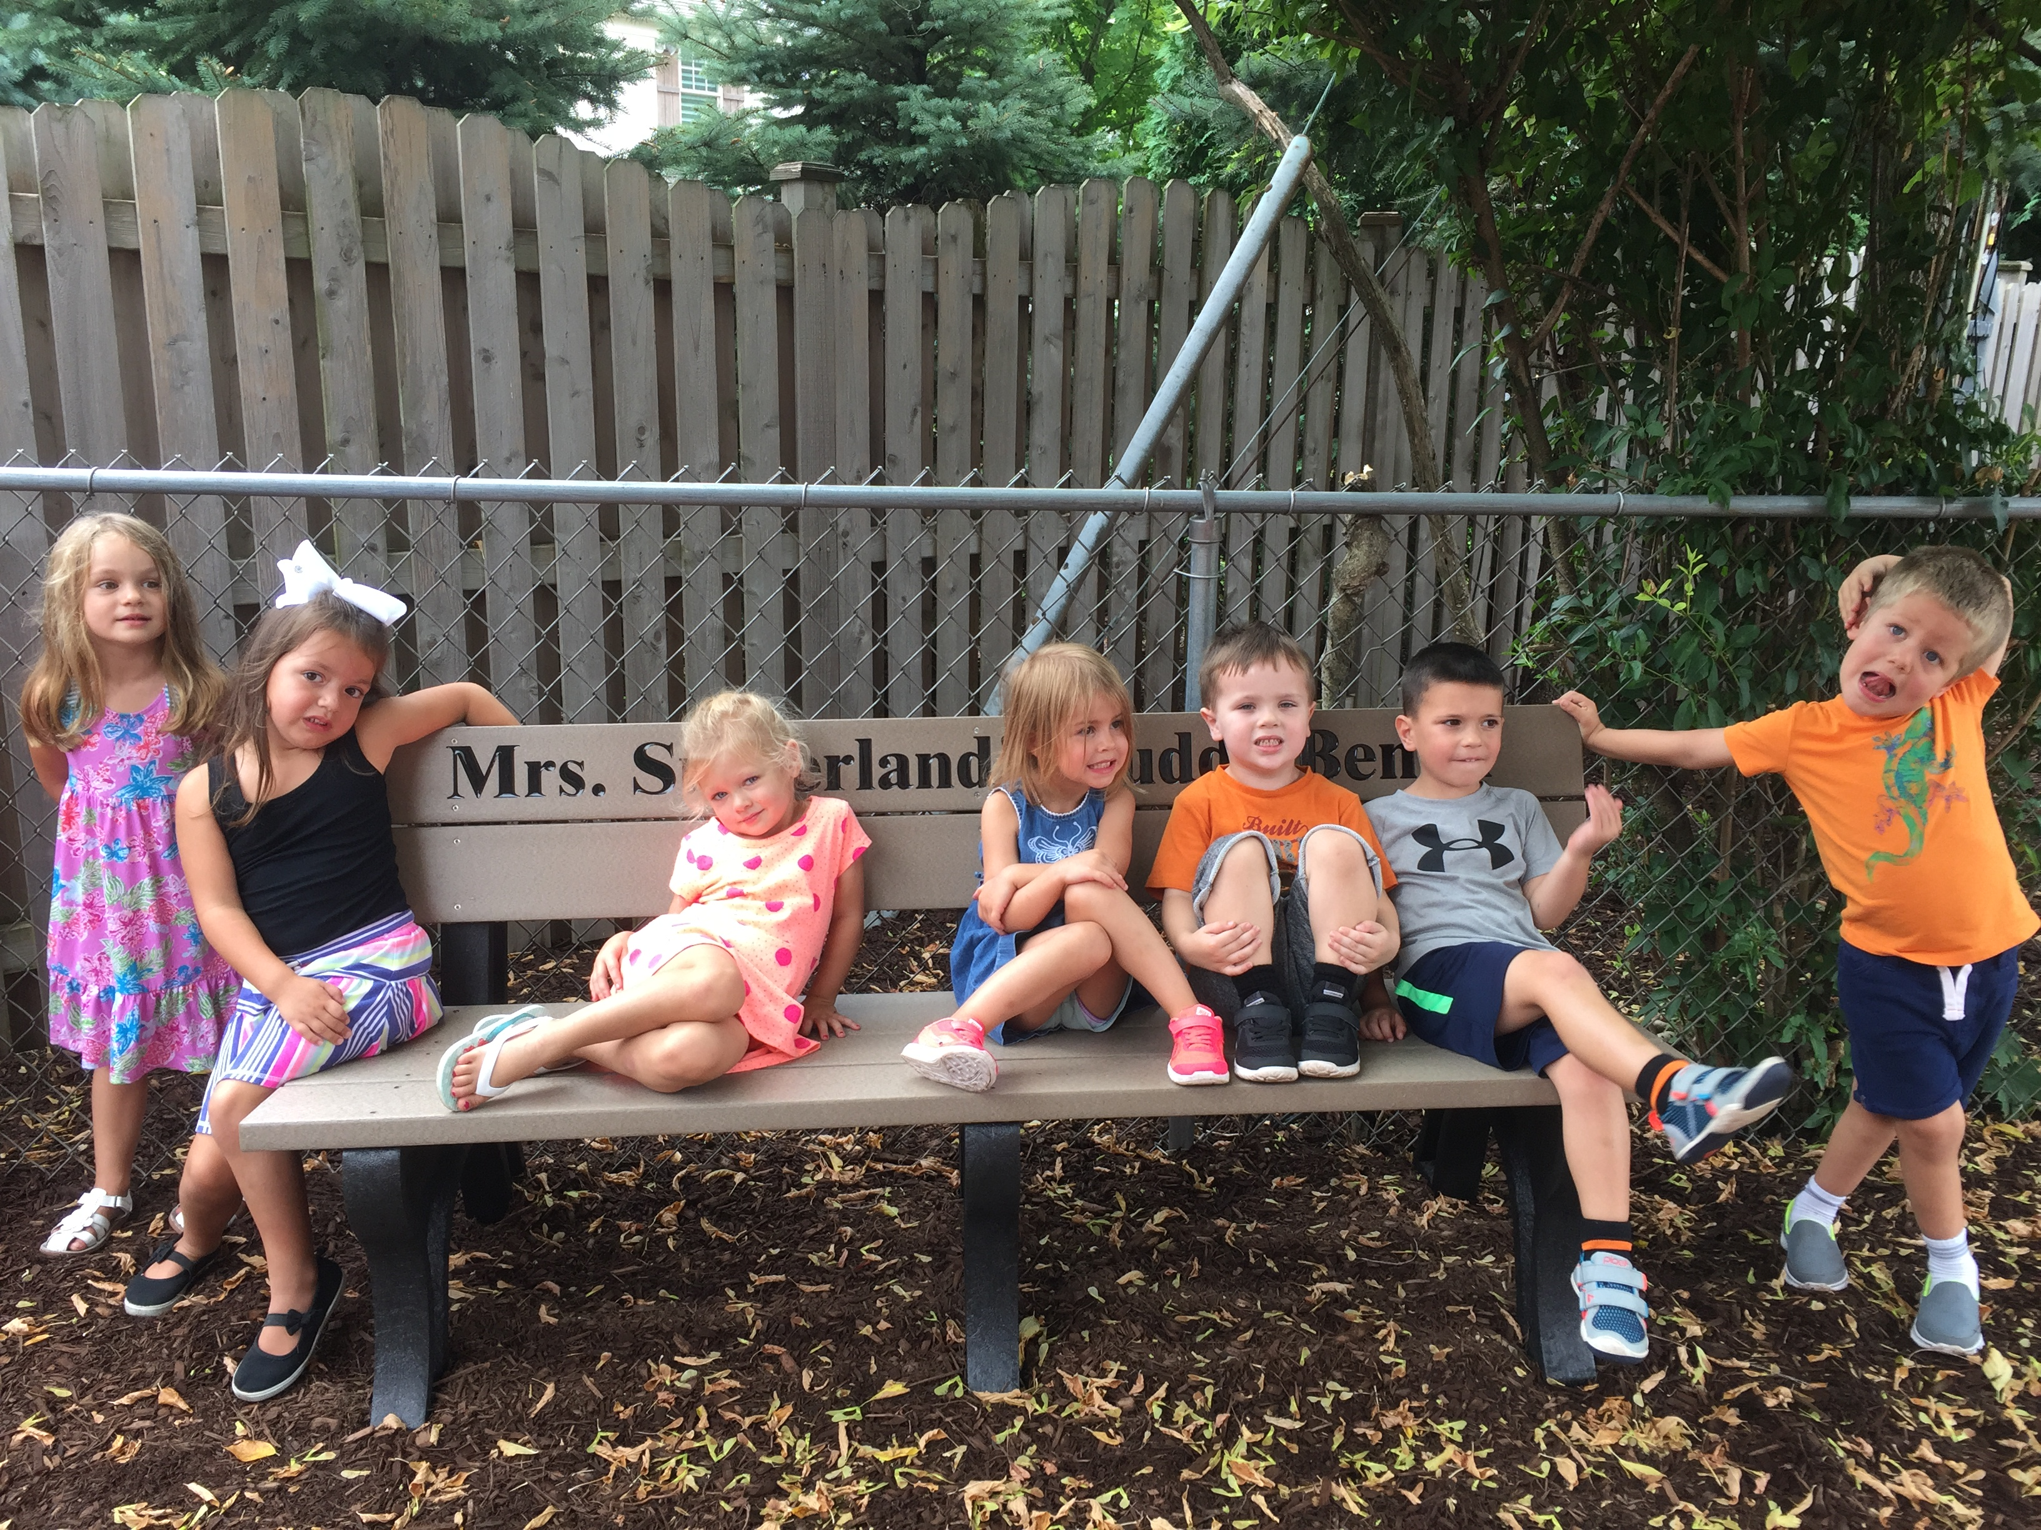

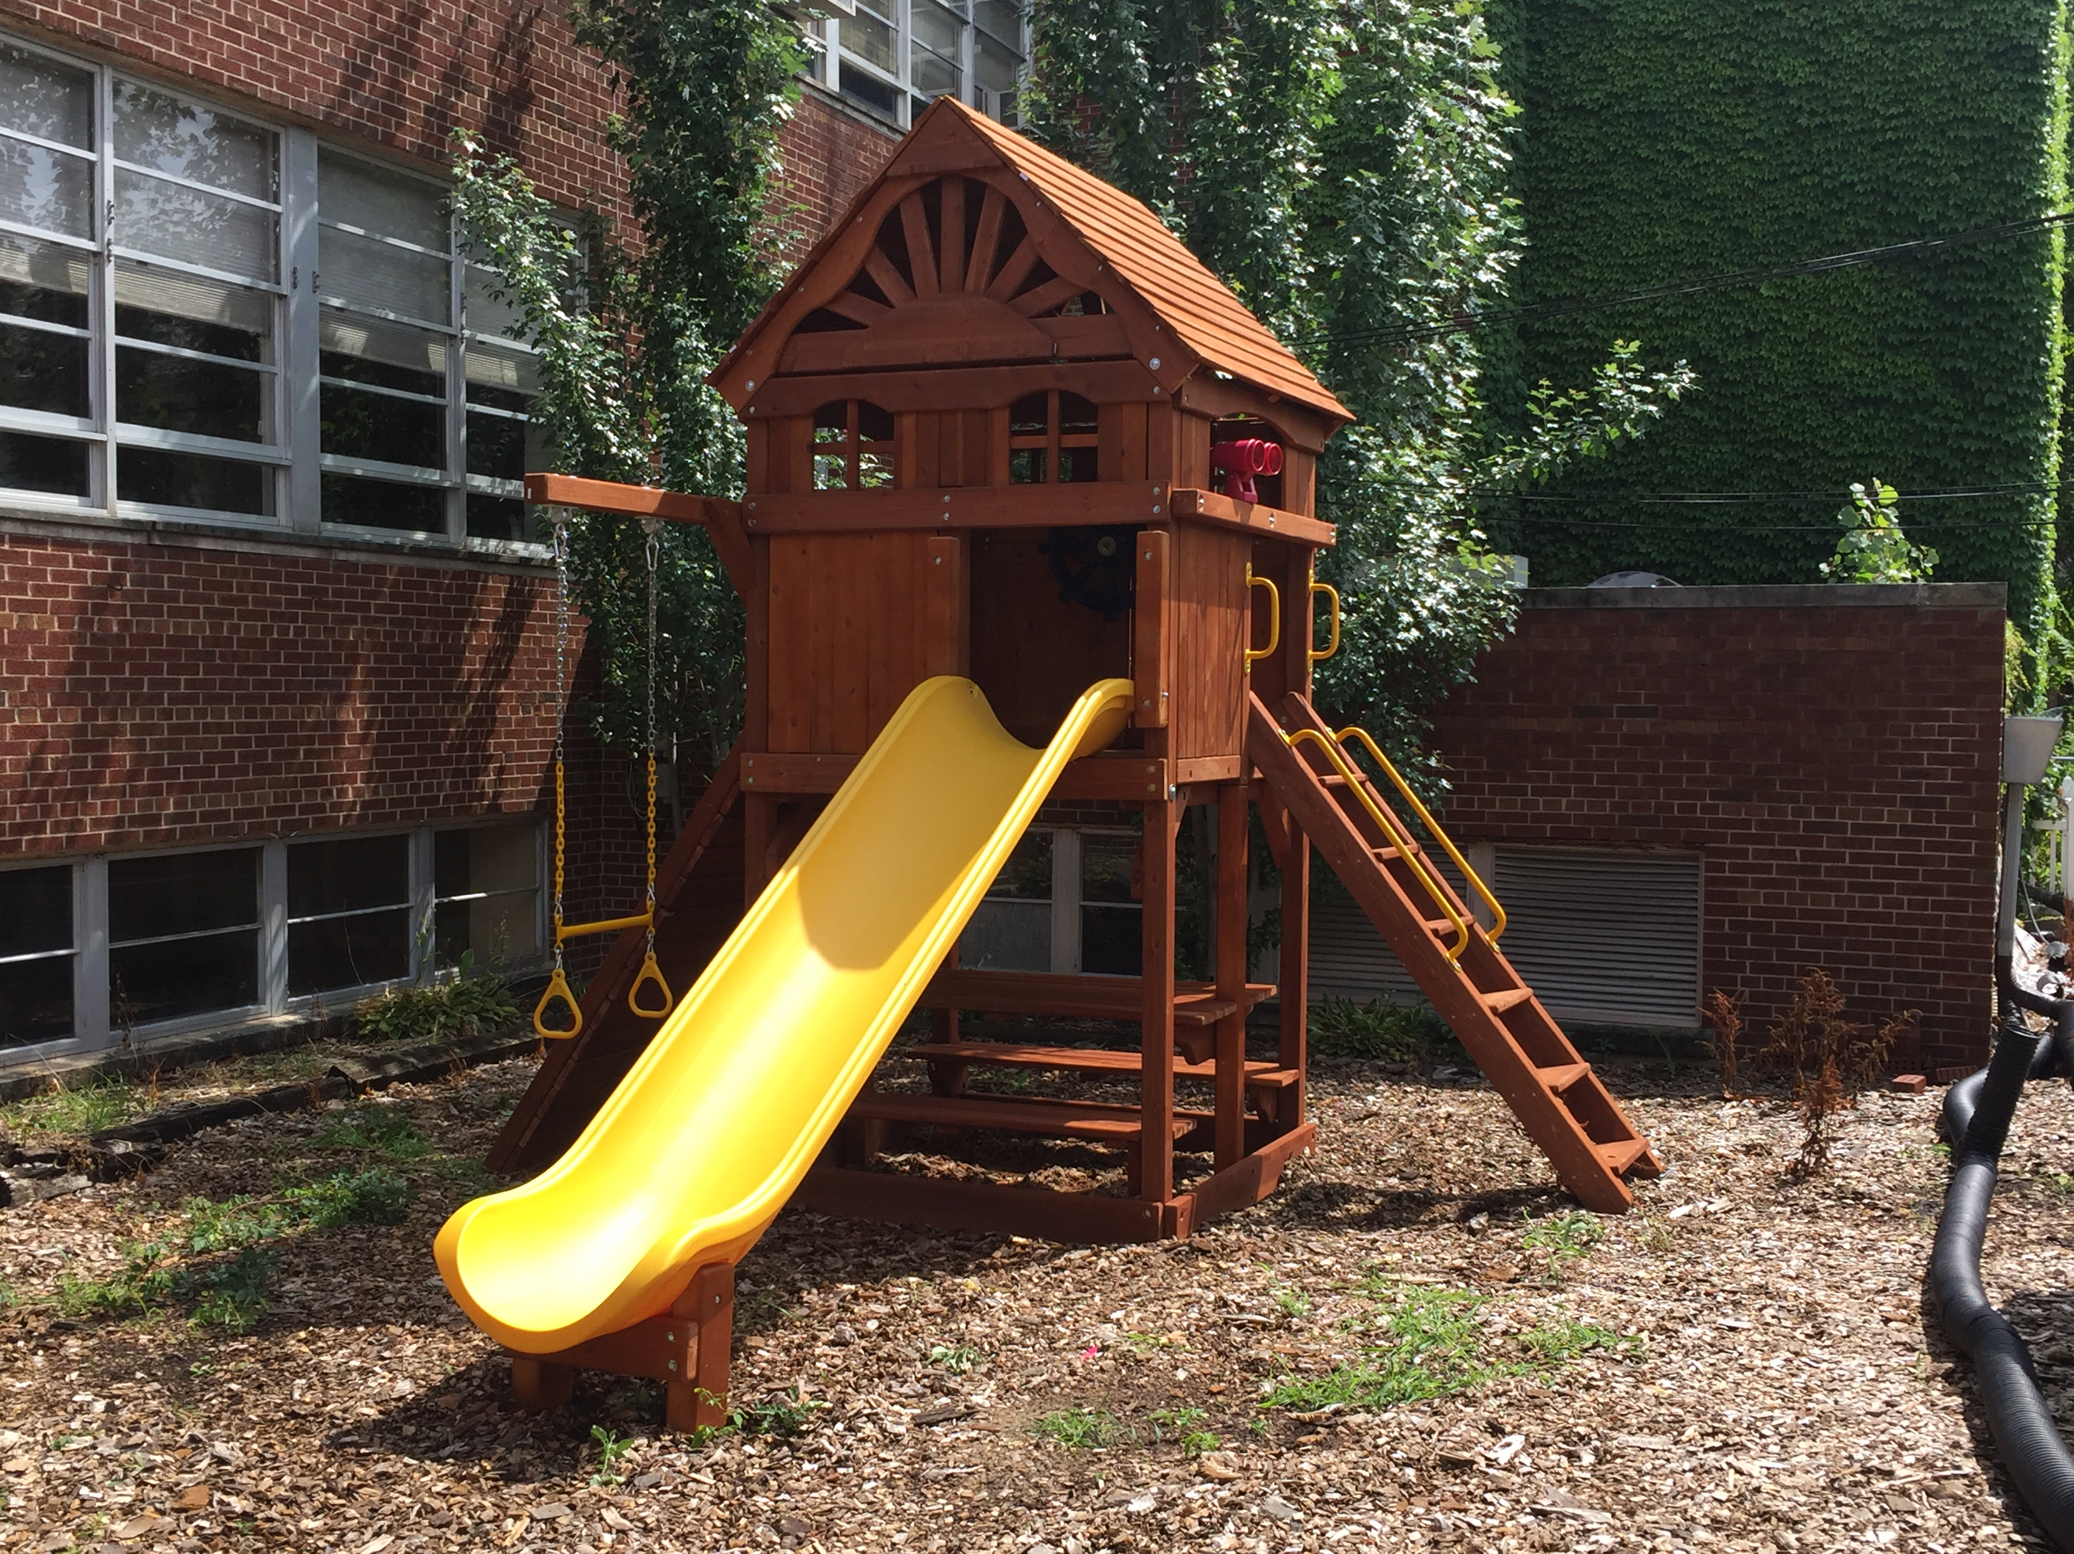

Our new play structure!

Play’s the Thing
Our learning philosophy here at Tree Town is learn through play. We teach academic skills through a play based experience. This is recognized by many educators as the optimal way to teach young children. This is an excerpt of an article in the Washington Post about the importance of play.

“Preschool years are not only optimal for children to learn though play, but also a critical developmental period. If children are not given enough natural movement and play experiences, they start their academic careers with a disadvantage. They are more likely to be clumsy, have difficulty paying attention, trouble controlling their emotions, utilize poor problem-solving methods, and demonstrate difficulties with social interactions. We are consistently seeing sensory, motor, and cognitive issues pop up more and more in later childhoods, partly because of inadequate opportunities to move and play at an early age.”

Curriculum
Our staff and students are getting adjusted to their new routines. We will be talking about many topics and concepts over the next few weeks. These subjects include: Friendship, Kindness, Nursery Rhymes, Shapes, Autumn, Apples, Pumpkins, the differences between Real and Pretend.
Our 3’s and 4’s classes will be talking a great deal about the changes that occur during the fall. Science, Math and Language Arts are incorporated in this unit, as they are with all our units. During our fall walk, 3’s and 4’s will talk about the changes they see in nature (leaves changing, birds flying south, squirrels storing food, etc). After our walk, the students will count, examine and sort the leaves, acorns and other treasures they gathered. Our 4’s will write sentences to go along with pictures their teacher took during this experience.

Tuition
Just a reminder….
Tuition is due Monday, October 2nd. Please drop in the Brown mail/tuition box at school which is in the staff room or mail to:
Hollye Morrow
471 S. Parkview
Elmhurst, IL 60126
If you have questions or need to make special arrangements please contact Hollye at (513) 260-4716 or at hollyehedges@hotmail.com prior to October 2, 2017. Please remember there is a $20 late fee for any payment 1-7 days late and a $50 late fee for payments made seven days after the due date.

Tuition and Snack Fee Amounts
Monday 2’s Class $335 = $35 snack fee = $370
Wednesday 2’s class - $380 + $35 snack fee = $415
2 day per week 3’s - $635 + $70 snack fee = $705
3’s Enrichment - $275+ $35 snack fee = $310
3 day per week 4’s - $885 + $105 snack fee = $990
4’s Enrichment - $300 + $35 snack fee = $335
Kid Town - $625 + $70 snack fee = $695

Charleston Wrap Orders – REMINDER!!!
Our Charleston Wrap Fundraiser runs through Friday, September 22rd . This is Tree Town’s biggest fund raiser of the year!

Directory
Revised class lists will be included in our phone directory, which will be printed during the month of October. The directory is provided as a way of introducing ourselves to each other. It should not be used for commercial purposes.

School Pictures
Individual and class pictures will be taken on Tuesday, November 14th and Wednesday, November 15th. Pictures will be taken on a pre-pay basis with satisfaction guaranteed through a money back refund. If you wish to have your child individually photographed, we must have the picture form returned before the picture can be taken.

Door Locking
We lock the door approximately 15 minutes after the scheduled start of class. You may enter through the church office after doors are locked. We unlock the doors approximately 5-10 minutes before the end of class.

Class Bulletin Board
Please remember to sign your child out and any children in your car pool at the attendance sheet on your class bulletin board. Please note the day’s activities are posted there, too, along with any special information pertaining to your class.

Change of Clothes
Accidents happen. Please provide your child with a change of clothes in his/her backpack. Please put the clothing in a large zip-lock bag so it is easy for us to grab.
If you have any old play clothes your child has outgrown, we would love to have them. We like to have some extra changes on hand in the room.

Halloween
Our three, four year olds and Kid Towners will have a chance to wear their costume to Tree Town on Monday, October 30th (four’s) and Tuesday, October 31st (3’s and Kid Town). We will have a piñata and some fun Halloween Games. Three’s and Four’s parents are welcome to stay during the first half hour to take pictures and see the children show their costume and tell all about it.

Separation
If your child cries during the first few weeks of school, don’t be concerned, this is normal. Children experience anxiety during new situations. Once children get adjusted to their routine, it will subside. It helps to have a good-bye ritual for both you and your child. You can read a book together, say a silly good-bye rhyme or just wash hands together. You and your child will know it is time for you to go and for them to start school. If you have any concerns, please talk to your teacher.

Harvest Open House
Please mark your calendar for our Harvest Open House. The MWF classes will be Monday, November 6th and the T/Th 3’s classes will be Tuesday, November 7th from 6:00 - 7:00 PM. The whole family comes to Tree Town at night! This is an opportunity for your child to show off their room. Moms, Dads, siblings and even Grandma and Grandpa are welcome to join us for pumpkin bread and snacks. Each family will have their picture taken in front of the teepee!

Tree Town Calendar

Sept. 22nd – Charleston Wrap Orders Due
Sept. 25th - Board Meeting
Oct. 2nd – Tuition Due
Oct. 9th – NO SCHOOL Columbus Day
Oct. 27th – Karen Ritter – Nature Presentation – Spiders – MWF 4’s
Oct. 30th – Board Meeting
Oct. 30th – Halloween Party MWF 4’s
Oct. 31st – Halloween Party T/Th 3’s and Kid Town
Nov. 6th – Harvest Open House – 4’s
Nov. 7th – Harvest Open House – 3’s
Nov. 14th – 3’s Pictures and Kid Town Pictures
Nov. 15th – 4’s Pictures
Nov. 16th – Thanksgiving Feast T/Th 3’s
Nov. 17th– Thanksgiving Feast MWF 3’s & 4’s
Nov. 20th – 24th – Thanksgiving Break
Nov. 27th – Board Meeting
Nov. 28th – Karen Ritter – Nature Presentation – Animal Coverings – T/Th 3’s
Nov. 28th – Karen Ritter – Nature Presentation – Native Americans – Kid Town

